Day05 Class

File permission

r(4) w(2) x(1) =7

Default Permission in Directory – 755

Default Permission in file - 644

Umask - 022

Full Permission – 777 (7 – user,7 –group,7 –others and read,write and execute)

Permission - 666

**Here are 10 Combination of the Permission you provide**

**1. -rw-r----x = 641 myfile1**

**2. -r---w---x = 421 myfile2**

**3. -rw-rwxr-- =674 myfile3**

**4. -rw-r-x--x =651 myfile4**

**5. -r-xr----x =541 myfile5**

**6. -rw-rw---x =661 myfile6**

**7. -r---wx—x =431 myfile7**

**8. -rw-r---wx =643 myfile8**

**9. -r-x-w---x =521 myfile9**

**10. -rw-rwxr-x =675 myfile10**

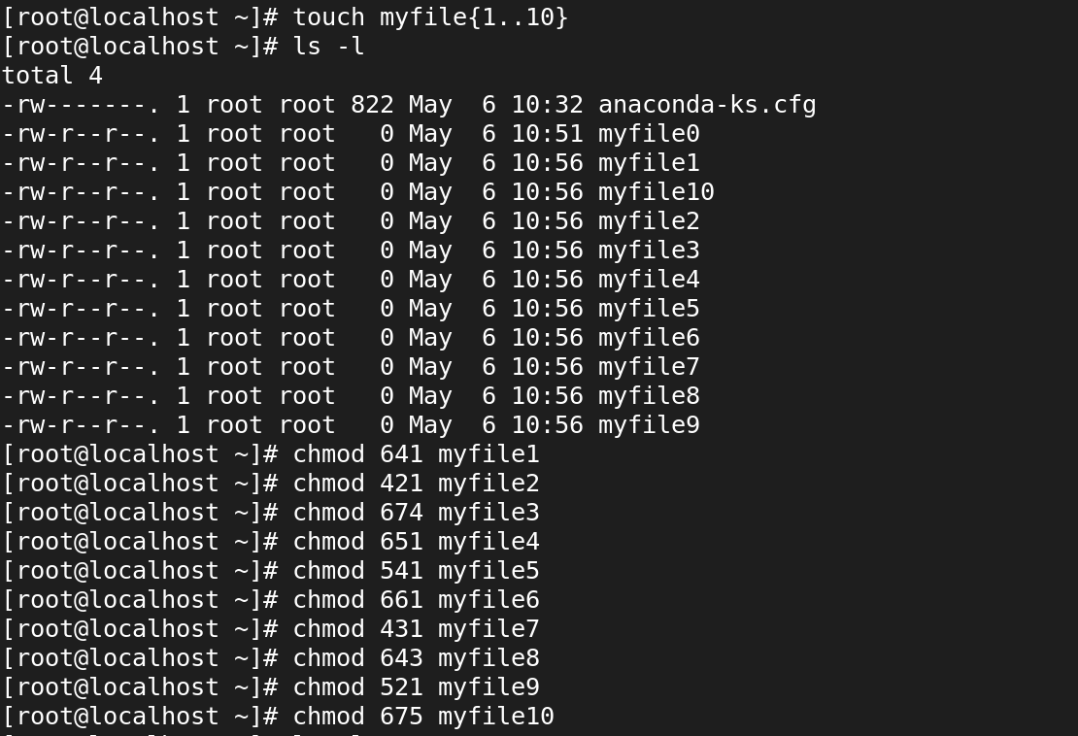

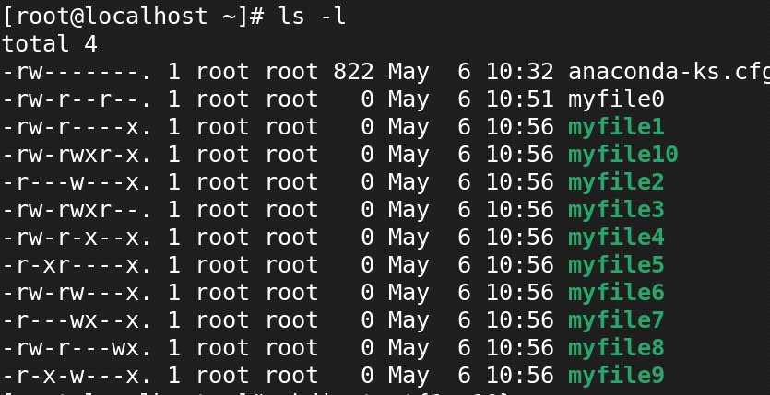

**Here are 10 Combination of the Permission you provide**

**drw-r----x = 641 test1**

**dr---w---x =421 test2**

**drw-rwxr-- = 674 test3**

**drw-r-x—x =651 test4**

**dr-xr----x = 541 test5**

**drw-rw---x = 661 test6**

**dr---wx--x = 431 test7**

**drw-r---wx =643 test8**

**dr-x-w---x = 521 test9**

**drw-rwxr-x = 675 test10**

